Name : Sakthi Manoj R Reg No : 192324236
PROGRAM 19
Build a Regression Model on an Advertising Dataset and Predict Sales
Aim:
To build a simple linear regression model using Spend to predict Sales and display a prediction.
Procedure:
Step 1: Open RStudio or the R console on your computer.
Step 2: Create numeric vectors for Spend and Sales, or load the advertising dataset if it is available.
Step 3: Build a linear regression model using lm(Sales ~ Spend).
Step 4: Use predict() with a new Spend value to predict Sales.
Step 5: Display the predicted Sales value.
Step 6: Observe the relationship between advertising spend and predicted sales.
Output :
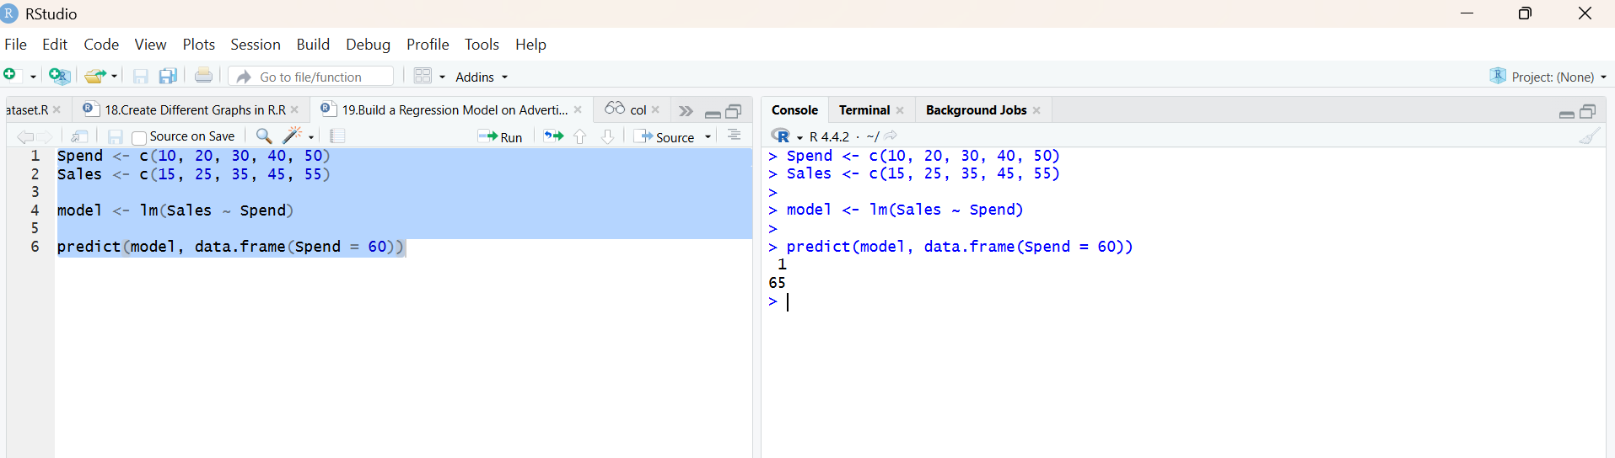
Result:
Hence the output is verified successfully.

